**Stat 2600 Project 11 (Group activity). Due: April 1, 2014. Names:**

**Marcel Englmaier, Kendrick Cline, Ryan DePrekel**

**Problems on Tests of Hypotheses**

1. Two ways of drying concrete (I and II) were investigated to see if type of drying had any effect on the strength (psi) of the concrete. So 7 batches (A through G) of concrete were mixed and divided into two batches, one of which was randomly assigned to drying method I and the other to method II. The results are:

Mix A B C D E F G  
Method I 3155 3240 3190 3520 3480 3220 3132   
Method II 3170 3220 3160 3530 3440 3210 3120

Let mu1 denote the true mean strength (psi) of concrete dried by Method I and mu2 denote the true mean strength (psi) of concrete dried by Method II. Read through the problem again and then choose the correct alternative.

H_0: mu1 = mu2 versus H_A: mu1 != mu2.

Note that the design is a *Randomized Paired Design*.

Form and print the differences and obtain a boxplot of them. Comment on the plot  
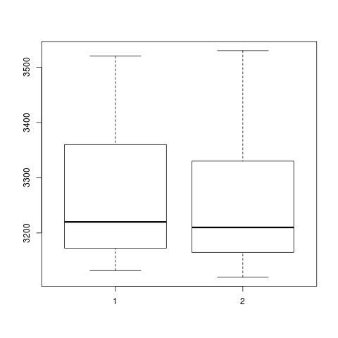  
The means of both samples are about the same.

Obtain the t-test of the hypotheses.

One Sample t-test

data: d

t = 1.6484, df = 6, p-value = 0.1504

alternative hypothesis: true mean is not equal to 0

95 percent confidence interval:

-6.020939 30.878082

sample estimates:

mean of x

12.42857

Using the p-value, conclude in terms of the problem.

do not reject because p-value > .1

Using the Wilcoxon test, obtain a confirmatory analysis. Using the p-value, conclude in terms of the problem.

Wilcoxon signed rank test with continuity correction

data: d

V = 22.5, p-value = 0.1755

alternative hypothesis: true location is not equal to 0

do not reject because p-value > .1

1. The threat of deteriorating pipelines is of major concern in the US. One new process, fuses a flexible liner through existing pipe. To investigate this new method, one test used 18 existing pipes (same age, etc.). Eight of these were treated with the new process while the other 10 were not treated. Then the tensile strength (psi) of each pipe was measured. The data are:

No Fusion: 2748 2700 2655 2822 2511 3149 3257 3213 3220 2753  
Fused: 3027 3356 3359 3297 3125 2910 2889 2902

Let mu1 denote the true mean tensile strength (psi) of the no fused pipe. and mu2 denote the true mean tensile strength (psi) of the fused pipe. Read through the problem again. *Note there is no statement such as "We think one method is preferred over the other.* So, we are interested in testing:

H_0: mu1 = mu2 versus H_A: mu1 != mu2.

Note that the design is a *Completely Randomized Design*.

1. Obtain a comparison stripchart. Comment

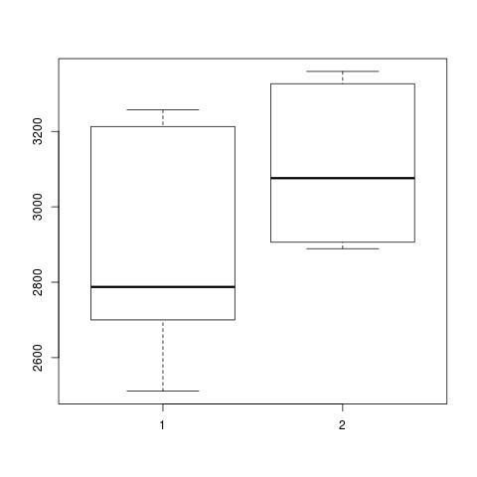  
that’s a pretty boxplot, with the means being very far apart

1. Obtain the t-test of the hypotheses.

t.test(nf,f)  
 Welch Two Sample t-test

data: noF and F

t = -1.8018, df = 15.944, p-value = 0.09051

alternative hypothesis: true difference in means is not equal to 0

95 percent confidence interval:

-446.96513 36.31513

sample estimates:

mean of x mean of y

2902.800 3108.125

1. Using the p-value, conclude in terms of the problem.

we do not accept noF, p-value is too low

1. Using the Wilcoxon test, obtain a confirmatory analysis. Using the p-value, conclude in terms of the problem.

Wilcoxon rank sum test

data: noF and F

W = 20, p-value = 0.08314

alternative hypothesis: true location shift is not equal to 0

95 percent confidence interval:

-534 95

sample estimates:

difference in location

-195.5   
  
concluded not accepted